Arlington Cemetery *Also known as: Old Arlington Cemetery
801 Mary St., Arlington, Tarrant County, Texas USA
Postal Code: 76010

Interactive map and GPS data:
GPS Coordinates: Latitude: 32.72942, Longitude: -97.10264

http://www.findagrave.com/cgi-bin/fg.cgi?page=cr&CRid=1964401&CScn=arlington&CScntry=4&CSst=46&CScnty=2739&

Cemetery notes and/or description:
Located next to Parkdale Cemetery.

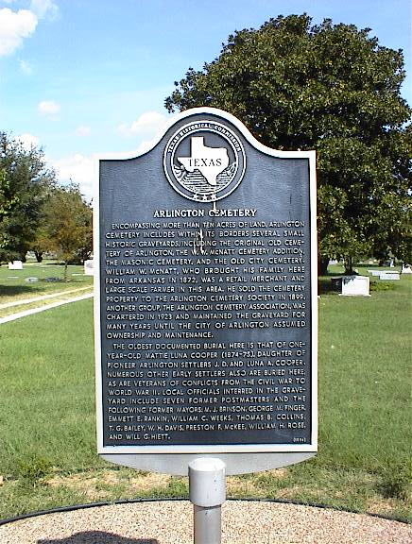
Marker Reads: Arlington Cemetery - Encompassing more than ten acres of land Arlington Cemetery includes within its borders several small historic graveyards, including the original old cemetery of Arlington, the W. W. McNatt Cemetery addition, the Masonic Cemetery, and the Old City Cemetery. William W. McNatt, who brought his family here from Arkansas in 1872, was a retail merchant and large scale farmer in this area. He sold the cemetery property to the Arlington Cemetery Society in 1899. Another group, the Arlington Cemetery Association, was chartered in 1923 and maintained the graveyard for many years until the city of Arlington assumed ownership and maintenance. The oldest documented burial here is that of one-year-old Mattie Luna Cooper (1874-75), daughter of pioneer Arlington settlers J. D. and Luna Copper. Numerous other early settlers also are buried here, as are veterans of conflicts from the Civil War to World War II. Local officials interred in the graveyard include seven former postmasters and the following former mayors: M. J. Brinson, George M. Finger, Emmett E. Rankin, Williams C. Weeks, Thomas B. Collins, T. G. Bailey, W. H. Davis, Preston F. McKee, William H. Rose, and Will G. Hiett. (1994)

