http://www.tn.gov/tsla/history/military/saw.htm

In the minds of most people, the Spanish American War, if remembered at all, began with the destruction of the battleship Maine on February 15, 1898, in the harbor at Havana. In April the American fleet effected a blockade of the harbor and the northern coast of Cuba. The gunboat Nashville, commanded by a Knoxville native, Washburn Maynard, fired the first shot of the war, sending a shell across the bow of the Spanish steamer Buena Ventura. President McKinley called for 125,000 troops, and on April 25 war was formally declared. | 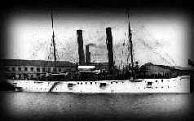  The Gunship Nashville

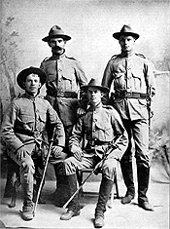  (L-R) Capt. Gaston O'Brien,  Capt. Nick Givens, Lt. T.H. Bates,  Capt. H.B. Myers | Tennessee followed its tradition of volunteerism in the spring and summer of 1898. Over 4000 men served in Tennessee's four Volunteer Infantry units. Of the four, only the First saw combat. The Second and Third were discharged before they saw action, and the Fourth served as occupying forces in Cuba after the war was officially over.  The men of the First were sent from Camp Merritt in California to help hold the Philippine Islands after the Filipino insurrection against Spanish colonial rule. Later, when Regular Army units were authorized to replace the volunteer units in the Philippines, a number of Tennesseans reenlisted in the Regular Army.

The Tennessee State Library and Archives (TSLA) holds published service abstracts (call number E725.8 .S62) for men in the First, Second, Third and Fourth Volunteer Infantry units. Service abstracts are arranged alphabetically in volumes transcribed by the WPA in the 1930s. The index following this introduction is taken from the abstracts; it is not a comprehensive listing of all Tennesseans who served in the Spanish American War. TSLA has no records of the men who served in Regular Army units. For service records of men who served in the Regular Army, and for Compiled Service Records and pension records of men in Tennessee's four volunteer infantry units, contact the National Archives and Records Administration. |  |  | 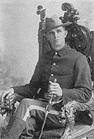  Sgt. Clement C. Jones  captured a Filipino flag
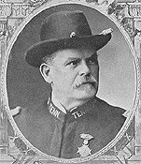
Col. William C. Smith
First Volunteer Infantry

First Volunteer Infantry
Colonel: William Crawford Smith
Lieutenant Colonel: Gracey Childers
Majors Albert B. Bayless, B. Frank Cheatham, John G. Maguire
Major and Surgeon: Richard A. Barr
Captain and Assistant Surgeon: R.M. Kirby Smith, Percy Jones
First Lieutenant and Adjutant: James K. Polk
First Lieutenant and Quartermaster: Andrew J. Duncan
Captain and Chaplain: Lewis J. Leland
Regiment discharged at Presidio, San Francisco, California November 23, 1899

Second Volunteer Infantry  Colonel: Kellar Anderson  Lieutenant Colonel: Thomas E. Patterson  Majors Frank H. Deffrey, Mark A. Walker, George W. Seay  Regiment discharged at Camp Fornance, Columbia, South Carolina February 8, 1899 | 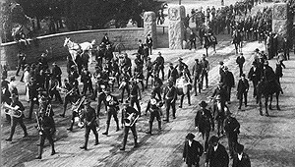Tennessee Band & Escort  Leaving Presido for Manilla

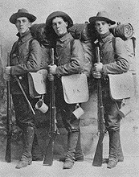  unidentified soldiers | Third Volunteer Infantry  Colonel: James P. Fyffe  Lieutenant Colonel: Daniel M. Coffman  Majors: William Brown, James W. Meeks, Edwin C. Ramage  Regiment discharged at Camp Shipp, Anniston, Alabama January 31, 1899

Fourth Volunteer Infantry  Colonel: George LeRoy Brown  Lieutenant Colonel: Harvey H. Hannah  Majors William C. Tatom, William O. Vertrees, (Eldridge Wright resigned October, 1898)  Major and Surgeon: Crum Eppler  Captain and Assistant Surgeon: J.W. McDonald, V.K. Earthman  First Lieutenant & Adjutant: Beauford McKinney  First Lieutenant & Quartermaster: Henry C. Gillispie  Captain and Chaplain: R.N. Price (Charles Hancock resigned October, 1898)  Regiment discharged at Savannah, Georgia,May 6, 1899 | 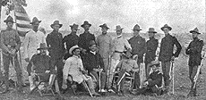  Lt. Col. Harvey H. Hannah  and Officers  Fourth Volunteer Infantry

Reading List:
The First Tennessee Regiment, United States Volunteers, compiled by Will T. Hale. Nashville, Marshall and bruce, 1899. 62 p.
The Fourth Tennessee Souvenir and Roster, Spanish American War, 1898-1899. Memphis, R.W. Page, n.d. [ca. 1899] 53 p.
Johnson, Cave. Roster of Company H and Clarksville Members of the First Tennessee Regiment. Clarksville, Press of the Times-Journal, 1898-1899. 23 p.
The Official and Pictorial Record of the War with Spain and Philippines including the Life, Messages and Papers of President McKinley with Fullest Information Respecting Cuba, Porto Rico, the Philippines and Hawaii, their Commerce, Climate and Productions; Embellished with fifteen hundred original illustrations. Washington, War Records Office, 1902. 631 p.

