http://www.usgwtombstones.org/kentucky/clinton.html
Beech Bottom Cemetery in Albany (Clinton County), Kentucky:
From Albany, KY, take US Hwy 127 South for 2 miles. Turn left on KY-696 and travel 3 miles. Turn right on KY-415 and go 2 miles. Turn left on Beech Bottom Cemetery Road.
Beaty Cemetery,
8 miles SE of Albany, KY, (Clinton CO. ??)
Beaty Cemetery Rd, 1 mile North of KY/TN state line
Map coordinates: 36 37.90 North x 86 3.25 West
100 yards NE of SR 968
Boring Cemetery is on the south side of Hwy 738, just past Lee's Chapel.
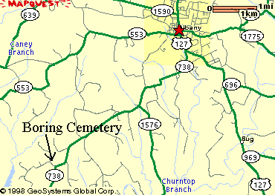
It might interest you to know that I am placing during the first week in October 1998 a Historical Marker on the Boring Cemetery in Clinton County. It only has a bunch of fieldstones, but in 1961 my grand-uncle James Edgar Amonette took me there and told me who was buried there. There are about 13 graves there, including Isaac and Catherine Conner Boring and probably Charles and Elizabeth Tipton Reneau.
~ J.D. Means
CAVE SPRINGS Cemetery: Located behind the Cave Springs Church
Davidson Cemetery is located in Clinton County Kentucky. The cemetery listing and photos were provided by Sherri Bradley. All readable stones were photographed and are linked here. There are approx. 60-70 graves that are marked with only fieldstones or are not marked at all.
Five Springs Cemetery is located in Clinton County Kentucky. The partial cemetery listing and photos were provided by Doxie Sheckels Cruz.
THE HOPKINS CEMETERY, Clinton County, Kentucky
Made available to The USGenWeb Archives by Bonnie A. Parker - bparker@csranet.com
This cemetery is located about two and one half miles north of the city of
Albany in Clinton county, near Commonwealth Highway Number 90. This cemetery
has about 45 marked graves, most of which are now illegible. It is in the
middle of private farmland, and not maintained, although it now has at least
a fence around it.This information was copied from all legible monuments in the Hopkins Cemetery
by Mrs. J.H. Cross, Lawrence I. Cross and Willie C. and Kay W. Cross, on Nov. 27, 1969.
RECTOR CEMETERY This small graveyard lies on a mound under a thicket of trees, on a farm just west of Static. It's about 100 yards south of the road, on the state line. I found many broken markers, and most of the ones with engraving had fallen over. Vegetation has grown over the area.

